Black Cat

Bat
Pumpkin
Ghost
Skeleton
Spider
Witch
Mummy
 | 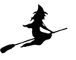 | 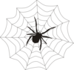 | 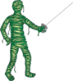
 | 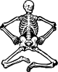 | 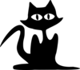 | 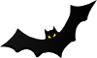
Halloween Copy and Paste
Name:

